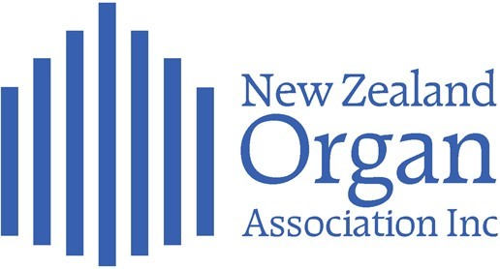
2024 NZ ORGAN FESTIVAL - DUNEDIN
(Organised for the NZOA by the Otago & Southland Organ Association)

Theme: Rising Stars
Matariki Weekend, 27th – 30th June 2024

REGISTRATION FORM
(Please complete one form person)

Name: (as shown on name tag) _______________________________________________________
E-mail address: _______________________________________________________
Preferred phone number: _______________________________________________________
Association (or town, if a personal member: ______________________________________________
Registration Fees:

Early bird” (if paid by 20th May) $375.00
Full registration (paid by 15th June) $400.00
(Please note: If you have a partner (or guest) who wishes to attend selected events, please let us know and we will arrange that and advise the cost).

If you would like to play for one of the church services on the Sunday Morning,

please indicate here
Please indicate if you have applied for the Developing Organist Opportunity

for the 2024 Festival

Please indicate if you have any specific dietary requirements and please
give details: __________________________________________________

If you will require transport to the Dunedin Airport after the Festival concert
(planned to finish by 3.30 p.m.) please indicate here and no of passengers.

If you are bringing a car to Dunedin, please advise if you would be able to
transport others to the various venues and how many passengers you could
take.
Return registration form / make payment to the Festival Registrar (Sue McLintock) by the final date: 15th June 2024
Email: (preferably) scan and e-mail to sandrmclintock@gmail.com: or post to Sue McLintock,
17 Elliffe Place, Shiel Hill, Dunedin 9013.
Please make payment to the following bank account by internet banking or direct bank deposit:
Otago & Southland Organ Association Inc. Westpac account: 030903 0434213 00
Please include your name and “Festival” with your payment.

